Trends of the Periodic table
Syllabus points

- The structure of the periodic table is based on the atomic number and the properties of the elements
- The elements of the periodic table show trends across periods and down main groups, including atomic radii, valencies, 1st ionisation energy and electronegativity as exemplified by groups 1, 2, 13-18 and period 3

Periodic table
- Its your best friend
- Arranged according to atomic number
- Typically atomic number above elemental symbol and mass below
- Horizontal rows = periods
- Vertical columns = group
- Main group elements 1, 2, 13-18
- Transition metals 3-12
- Lanthanois and actinoids in period 6 and 7

- Electron configuration
- The number of electrons in the valence shell increases across and period
- The number of valence electrons down a group remains constant
- Nobel gases have a full valence shell (outer shell) and therefore inert
- Electrostatic attraction
- Electrostatic attraction is the attraction between positive and negative charges
  - Found in holding atoms together (protons and electrons), holding molecules together (between atoms)
  - Coulomb's law can help explain trends in the periodic table
  - $F=\frac{q1q2}{r^{2}}$
    - F is the force of attraction
    - q1 and q2 are the amount of charge
    - R is the distance between those two charges
  - Therefore
    - the strength of the electrostatic attraction is directly proportional to the magnitude of the charges
When size of charge increases, force of attraction increases
- The strength of the electrostatic attraction is inversely proportional to the distance between charges
  - When the distance between the charges increases, the strength between the charges decreases

Core charge (also effective nuclear charge)
- The measure of attractive force felt by the valence electron towards the nucleus
- Core charge = number of protons - number of total inner-shell electrons
  - Also the number of valence electrons

- Valence electrons are attracted to the nucleus but also repelled by electrons in energy levels closer to the nucleus, reducing their attraction to the nucleus
- Core charge remains constant down a group as they have the same number of valence electrons
- Core charge increases across a period as the distance between the valence electrons remains constant (same shell) but the number of protons increases

- Atomic radius
- The size of the atom
  - i.e the distance between the nucleus and the valence electrons
- Atomic radius increases down a group
  - The core charge stays constant and the number of electron shells increase
- Atomic radius decreases across a period
  - The number of shells remains constant and the core charge increases. The valence electrons are more strongly attracted to the nucleus

- Ionisation energy
- The valence electrons are held in place due to the electrostatic attraction to the nucleus.
- If enough energy is used, this electrostatic attraction can be broken and the electron removed from the atom
  - This process is called ionisation
- The valence electrons are removed first as they are further away and the least strongly held

- The energy required to remove one electron from an atom in gas phase is the ionisation energy
- The energy required to remove the first valence electron from an atom in gas phase is the first ionisation energy
- The more energy required for ionisation represents how strongly the valence electron is attracted to the nucleus

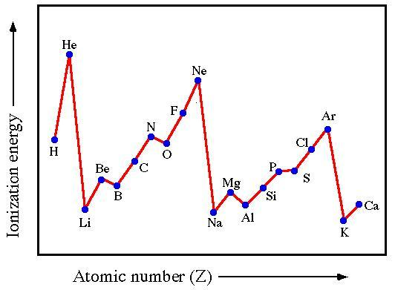
- As the core charge increases across a period, so does the ionisation energy
- As the atomic radius increases down a group, the electrons are further away from the nucleus and therefore removed more easily lower down a group

- Successive ionisation energy is the energy required to remove all electrons of an atom in order
- Patterns can be noted in graphs as to the locations of the shells
- A gradual increase in energy means the electrons are located in the same shell where a significant differences means the electron removed is in another energy level/shell
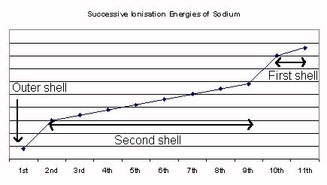

- Electronegativity
- Electronegativity is the ability of an atom to attract electrons in a covalent bond towards itself
- The more strongly the valence electrons are attracted to the nucleus of an atom, the greater the electronegativity
- This strength of attraction depends on the amount of charge and distance between charges involved
- Electronegativity decreases down a group as the core charge stays constant and the atomic radius increases therefore the electrons are less attracted to the nucleus
- Electronegativity increases across a period as the number of shells remains constant and the core charge increases therefore the valence electrons are more strongly attracted to the nucleus

- This is useful for predicting types of bonding (chapter 5 and 6)

- Metallic character
- Metals conduct electricity where non-metals usually don’t
- The differences in properties is related to the number of electrons in the outer shell
  - 1-3 electrons in outer shell = behave like metal
  - 4+ valence electrons =behave like non metal
- Metalloids have properties exhibited by both metals and non-metals
- Therefore metallic character is how closely an element exhibits properties associated with metals i.e readily loses electron/s to form a cation

Questions :Pearson 3.3 Review p.61

Vocabulary words

- Period
- Group
- Valence shell
- Inert
- Core charge
- Atomic radius
- Electrostatic attraction
- Ionisation
- Ionisation energy
- First ionisation energy
- Successive ionisation energy
- Electronegativity
- Metallic character

